**Christmas Eve**

December 24, 2024

**TO OUR GUESTS**

*Welcome! May your worship with us add inspiration and light to your celebration of Christmas. Visitors, please fill out the Welcome Card found on the back of each pew, and give it to Pastor after the service and receive a special gift. Have a very Merry Christmas!*

**ORDER OF SERVICE**

**PRELUDE**

I Am So Glad Each Christmas Eve Anthony Giamanco

**HANDBELLS**

Song of the Angels arranged by Anna Laura Page

**PROCESSIONAL**  Hymnal p. 379 sts. 1-3

**O Come, All Ye Faithful**

**O come, all ye faithful, joyful and triumphant,**

**O come ye, O come ye, to Bethlehem.**

**Come and behold Him, born the King of angels;**

**Refrain: O come, let us adore Him,**

**O come, let us adore Him,**

**O come, let us adore Him,**

**Christ the Lord.**

**Highest, most holy, Light of Light Eternal,**

**Born of a virgin, a mortal He comes**

**Son of the Father, now in flesh appearing! Refrain:**

**Sing, choirs of angels, sing in exultation;**

**Sing, all ye citizens of heaven above!**

**Glory to God, in the highest; Refrain:**

**WELCOME**

**INVOCATION**

The sign of the cross (†) may be made by all in remembrance of their Baptism.

P: In the name of the Father and of the (†) Son and of the Holy Spirit.

**C: Amen.**

P: Let us pray.

O God, You make us glad with the yearly remembrance of the birth of Your only-begotten Son, Jesus Christ. You make this most holy night to shine with the brightness of the true Light. Grant that as we have known the mysteries of that Light on earth we may also come to the fullness of His joys in heaven; through the same Jesus Christ, Your Son, our Lord, who lives and reigns with You and the Holy Spirit, one God, now and forever.

C: Amen.

P: The virgin will bear a son, and you shall call His name Jesus.

C. For He will save His people from their sins.

P: For unto us a child is born

C: unto us a Son is given.

P: and His name shall be Wonderful Counselor, Mighty God,

C: Everlasting Father, Prince of Peace.

P: Shout joyfully to the Lord, all the earth;

C: Break forth in song, rejoice, and sing praises.

*(Please be seated)*

**HYMN** Hymnal p. 380 sts. 1,3

**Hark! The Herald Angels Sing**

**Hark! The herald angels sing, “Glory to the newborn King;**

**Peace on earth and mercy mild, God and sinners reconciled!”**

**Joyful, all ye nations, rise, Join the triumph of the skies;**

**With th’angelic host proclaim, “Christ is born in Bethlehem!”**

**Hark! The herald angels sing, “Glory to the newborn King!”**

**Hail, the heav’n born Prince of Peace! Hail, the Sun of Righteousness!**

**Light and life to all He brings, Ris’n with healing in His wings.**

**Mild He lays His glory by, Born that man no more may die,**

**Born to raise the sons of earth, Born to give them second birth.**

**Hark! The herald angels sing, “Glory to the newborn King!”**

**FIRST READING** Micah 5:2-5

L: The first reading for Christmas Eve is from chapter five of Micah.

*The promised Savior is to be born in Bethlehem.*

But you, O Bethlehem of Ephrathah,

who are one of the little clans of Judah,

from you shall come forth for Me

one who is to rule in Israel,

whose origin is from of old,

from ancient days.

Therefore he shall give them up until the time

when she who is in labor has brought forth;

then the rest of his kindred shall return

to the people of Israel.

And he shall stand and feed his flock in the strength of the Lord,

in the majesty of the name of the Lord his God.

And they shall live secure, for now He shall be great

to the ends of the earth;

and He shall be the one of peace.

*Following the reading...*

L: This is the Word of our Lord.

**C: Thanks be to God.**

**HYMN** Hymnal p. 361 sts. 1,4

**O Little Town of Bethlehem**

**O little town of Bethlehem, How still we see thee lie!  
Above thy deep and dreamless sleep The silent stars go by;  
Yet in thy dark streets shineth The Everlasting Light.  
The hopes and fears of all the years Are met in thee tonight.**

**O holy child of Bethlehem, Descend to us, we pray;  
Cast out our sin, and enter in, Be born in us today.  
We hear the Christmas angels, The great glad tidings tell;  
O come to us, abide with us, Our Lord Immanuel!**

**SECOND READING** 1 John 4:7-16

L: The second reading is from chapter four of 1 John.

*God Is Love.*

Beloved, let us love one another, for love is from God, and whoever loves has been born of God and knows God. Anyone who does not love does not know God, because God is love.In this the love of God was made manifest among us, that God sent his only Son into the world, so that we might live through Him. In this is love, not that we have loved God but that He loved us and sent His Son to be the propitiation for our sins. Beloved, if God so loved us, we also ought to love one another.No one has ever seen God; if we love one another, God abides in us and His love is perfected in us.

By this we know that we abide in Him and He in us, because He has given us of His Spirit.And we have seen and testify that the Father has sent His Son to be the Savior of the world. Whoever confesses that Jesus is the Son of God, God abides in him, and he in God. So we have come to know and to believe the love that God has for us.  God is love, andwhoever abides in love abides in God, and God abides in him.

*Following the reading...*

L: This is the Word of our Lord.

**C: Thanks be to God.**

**HYMN** Hymnal p. 384 sts. 1,3,5

**Of the Father’s Love Begotten**

**Of the Father’s love begotten Ere the worlds began to be,  
He is Alpha and Omega, He the source, the ending He,  
Of the things that are, that have been, And that future years shall see  
Evermore and evermore.**

**This is He who seers in old time Chanted of with one accord,   
Whom the voices of the prophets Promised in their faithful word.  
Now He shines, the long expected; Let creation praise its Lord  
Evermore and evermore.**

*(Please rise)***Christ, to Thee, with God the Father, And, O Holy Ghost, to Thee**

**Hymn and chant and high thanksgiving And unending praises be,**

**Honor, glory, and dominion, And eternal victory Evermore and evermore.**

**HOLY GOSPEL** Luke 2:1-20

P: The Holy Gospel is according to St. Luke, chapter two.

**C: Glory to You, O Lord.**

*Our Savior is born.*

And it came to pass in those days, that there went out a decree from Caesar Augustus that all the world should be taxed. (And this taxing was first made when Cyrenius was governor of Syria.) And all went to be taxed, every one into his own city. And Joseph also went up from Galilee, out of the city of Nazareth, into Judaea, unto the city of David, which is called Bethlehem; (because he was of the house and lineage of David:) To be taxed with Mary his espoused wife, being great with child. And so it was, that, while they were there, the days were accomplished that she should be delivered. And she brought forth her firstborn son, and wrapped him in swaddling clothes, and laid Him in a manger; because there was no room for them in the inn.

And there were in the same country shepherds abiding in the field, keeping watch over their flock by night. And, lo, the angel of the Lord came upon them, and the glory of the Lord shone round about them: and they were sore afraid. And the angel said unto them, Fear not: for, behold, I bring you good tidings of great joy, which shall be to all people. For unto you is born this day in the city of David a Saviour, which is Christ the Lord. And this shall be a sign unto you; Ye shall find the babe wrapped in swaddling clothes, lying in a manger. And suddenly there was with the angel a multitude of the heavenly host praising God, and saying, Glory to God in the highest, and on earth peace, good will toward men.

And it came to pass, as the angels were gone away from them into heaven, the shepherds said one to another, Let us now go even unto Bethlehem, and see this thing which is come to pass, which the Lord hath made known unto us. And they came with haste, and found Mary, and Joseph, and the babe lying in a manger. And when they had seen it, they made known abroad the saying which was told them concerning this child. And all they that heard it wondered at those things which were told them by the shepherds.

But Mary kept all these things, and pondered them in her heart. And the shepherds returned, glorifying and praising God for all the things that they had heard and seen, as it was told unto them.

*Following the reading...*

P: This is the Gospel of the Lord.

**C:Praise to You, O Christ.**

**HYMN** Hymnal p. 364

**Away in a Manger**

**Away in a manger, no crib for a bed,**

**The little Lord Jesus laid down His sweet head.**

**The stars in the sky looked down where He lay,**

**The little Lord Jesus asleep on the hay.**

**The cattle are lowing, the baby awakes,**

**But little Lord Jesus, no crying He makes.**

**I love Thee, Lord Jesus! Look down from the sky,**

**And stay by my cradle till morning is nigh.**

**Be near me, Lord Jesus; I ask Thee to stay**

**Close by me forever and love me, I pray.**

**Bless all the dear children in Thy tender care,**

**And take us to heaven to live with Thee there.**

**SERMON1**

**OFFERING OF OUR TITHES AND GIFTS**

HANDBELLS

Lo How a Rose E’re Blooming. Arranged by Tyleen Stults

OFFERING SONG

**What Child Is This** Hymnal p. 370 sts. 1,3

**What child is this, who, laid to rest, On Mary's lap is sleeping?**

**Whom angels greet with anthems sweet**

**While shepherds watch are keeping?**

**This, this is Christ the king, Whom shepherds guard and angels sing;**

**Haste, haste to bring Him laud, The babe, the son of Mary!**

**So bring Him incense, gold, and myrrh;**

**Come, peasant, king, to own Him.**

**The King of kings salvation brings; Let loving hearts enthrone Him.**

**Raise, raise the song on high, The virgin sings her lullaby;**

**Joy, joy. for Christ is born. The babe, the son of Mary!**

**PRAYER OF THE CHURCH**

P:  Let us pray for ourselves, the church, and the world.

For a blessed celebration of Christmas, that the music, lights, food, gatherings and gifts of this season would lead us to receive and worship our Savior that we would know the joys that only He can bring, we pray,

**C:  hear us, heavenly Father.**

P: For those who are sick, injured, or hospitalized, that the abiding love of Jesus may be their comfort and strength, we pray,

**C:  hear us, heavenly Father.**

P:  For those who suffer depression, sadness, and grief, especially at this time of year, that in the midst of their deep darkness, the ever-shining light of Christ may renew their joy and gladness, we pray,

**C:  hear us, heavenly Father.**

P:  For all who travel, that they may arrive safely at their destinations and enjoy the company of family and friends, we pray,

**C:  hear us, heavenly Father.**

P:  For the rulers of nations and for all of our elected leaders, that their governing may reflect the peace, justice, and righteousness of the Child born Wonderful Counselor, Mighty God, Everlasting Father, and Prince of Peace, we pray,

**C:  hear us, heavenly Father.**

P:  For all who serve in our armed forces and are away from home during this festive season, for our enemies, and for all victims of violence and war, that their lives may be touched by the Prince of Peace, we pray,

**C:  hear us, heavenly Father.**

P:  Exulting in the birth of our Savior, abiding in His love, and looking forward to His coming again, we entrust all for whom we pray to You, Father, Son, and Holy Spirit now and forever.

**C:  Amen.**

CHOIROn This Still and Silent Night Loni Smith

In manger bed He lies, the glorious King of light,

and all is calm as angels sing on this still and silent night.

The shepherds humbly kneel; how precious is the sight,

and Mary cradles heaven's Heir on this still and silent night.

Hear Mary softly singing beneath the stars so bright,

her songs of love and praise on this still and silent night,

holy night! Salvation's joy has come, God's glory our delight.

And now new hope to us is given on this still and silent night.

On this still and silent night, on this still and silent night,

on this still and silent night!

**THE SERVICE OF HOLY COMMUNION**

The Lord’s Supper (Holy Communion) is being celebrated in today’s service. In preparation for that, please be reminded that the bread and wine of the Lord’s Supper are not merely representations or symbols of Jesus’ body and blood but Jesus’ body and blood sacrificed on the cross are present in, with, and under the bread and wine (The Real Presence). How is this possible? This is beyond human understanding, but we remember that with God all things are possible. This truth is a divine mystery instituted by Jesus, taught by his Apostles, fervently held by the Christian church, and one in which we participate through faith. To be properly prepared to receive this sacrament, you must:

1)Recognize that you have indeed sinned against God and other people and are accountable to God for those sins;

2) Be sorry (repentant) for those sins;

3) Believe that in this sacrament Jesus bestows forgiveness, life, and salvation; and

4) Sincerely desire to live a godly life from this point forward.

If you are not a member of Christ Lutheran Church, please speak with the pastor before receiving communion here for the first time. If you choose to come forward to receive a blessing rather than theLord’s Supper, indicate this by crossing your arms over your chest.

**CONFESSION AND ABSOLUTION**3

P: Beloved in the Lord, since it is our intention to receive the Holy Supper of our Lord Jesus Christ, let us acknowledge our sin before God and each other and affirm our need for His grace and mercy. Let us also receive His promise of the forgiveness of our sins, eternal life and salvation by means of His Word of absolution and His pledge that He has reconciled us to Himself in the body and blood of the Lord Jesus Christ.

*(We take a moment of silence before the Lord as we call to mind how we have not properly loved Him, ourselves, or other people.)*

**C: Almighty God, have mercy upon us, forgive us our sins, and lead us to everlasting life. Amen**

P: Almighty God, in His mercy has given His Son to die for you. For His sake He forgives you all your sins. As a called and ordained servant of Christ and by His authority, I forgive you your sins in the name of the Father and of the (†) Son and of the Holy Spirit.

**C: Amen.**

**PREFACE**

P: The Lord be with you. **C: And also with you.**

P: Lift up your hearts. **C: We lift them to the Lord.**

P: Let us give thanks to the Lord our God. **C: It is right to give Him thanks and praise.**

P: It is truly good, right, and salutary that we should at all times and in all places give thanks to You, O Lord, holy Father, almighty and everlasting God, for the countless blessings You so freely bestow on us and all creation. Above all, we give thanks for Your boundless love shown to us when You sent Your only-begotten Son, Jesus Christ, into our flesh and laid on Him our sin, giving Him into death that we might not die eternally. Because He is now risen from the dead and lives and reigns to all eternity, all who believe in Him will overcome sin and death and will rise again to new life. Therefore with angels and archangels and with all the company of heaven we laud and magnify Your glorious name, evermore praising You and saying:

**SANCTUS**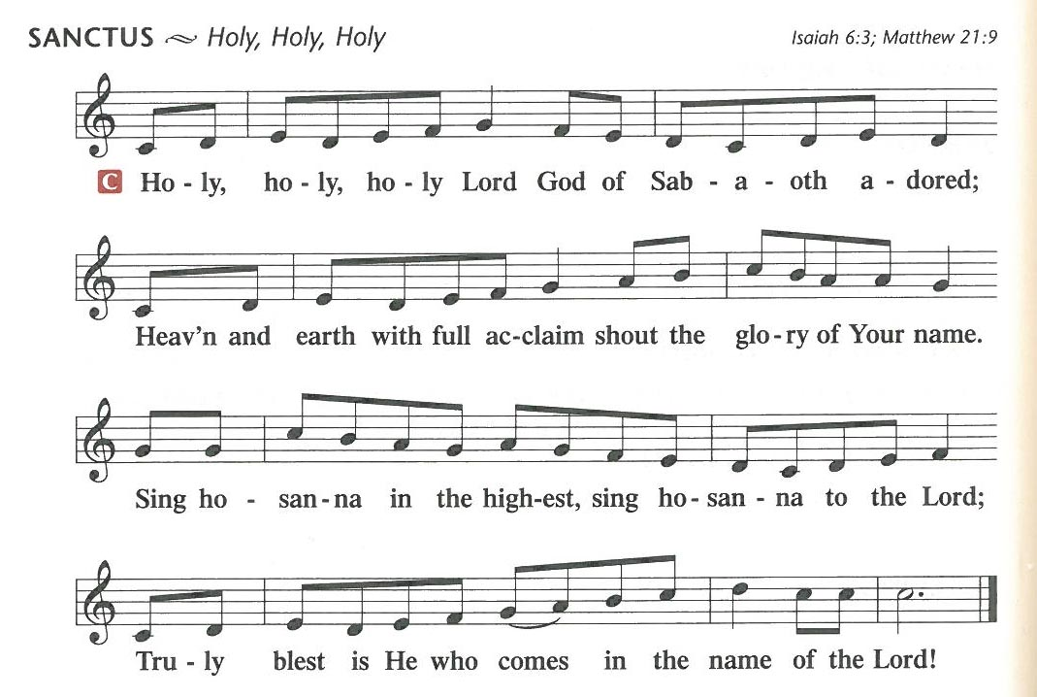

**PRAYER OF THANKSGIVING**

P: Blessed are You, O Lord our God, king of all creation, for You have had mercy on us and given Your only-begotten Son that whoever believes in Him should not perish but have eternal life.

In the beginning You created all things by Your Word; and in the fullness of time Your Word became flesh and dwelt among us, full of grace and truth.

Let Your Word made flesh dwell richly among us that, faithfully eating His body and drinking His blood, we may receive the fullness of Your grace and truth in Christ Jesus, our Lord.

Hear us as we pray in His name and as He has taught us:

THE LORD'S PRAYER

Our Father who art in Heaven, hallowed be Thy name, Thy kingdom come, Thy will be done on Earth as it is in Heaven. Give us this day our daily bread; and forgive us our trespasses as we forgive those who trespass against us; and lead us not into temptation, but deliver us from evil. For Thine is the kingdom and the power and the glory forever and ever. Amen.

**THE WORDS OF OUR LORD**

P: Our Lord Jesus Christ, on the night He was betrayed, took bread, and when He had given thanks, He broke it and gave it to the disciples and said: “Take, eat, this is My body, which is given for you. This do in remembrance of Me.”

In the same way also He took the cup after supper, and when He had given thanks, He gave it to them, saying: “Drink of it, all of you; this cup is the new testament in My blood, which is shed for the forgiveness of sins. This do, as often as you drink it, in remembrance of Me.”

**PAX DOMINI**

P: The peace of the Lord be with you in all ways.  
**C: Amen.**

**AGNUS DEI**

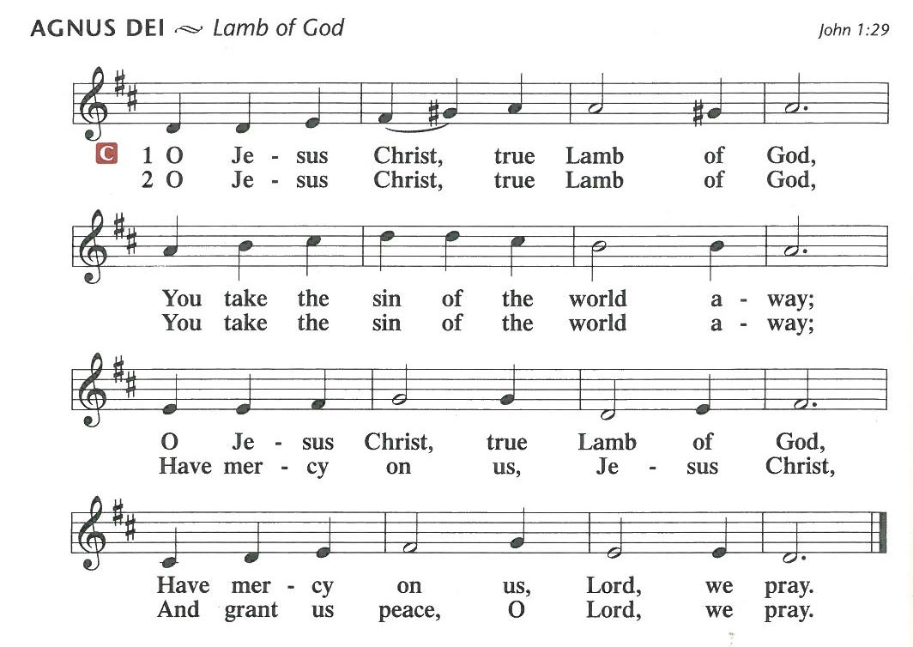

DISTRIBUTION

*Form a line at the communion rail starting at the left side. When the line is half full, begin filling it in from the right side. When invited, approach the rail and kneel/stand. After communion, exit through the right doorway, place individual communion cups in the tray, and proceed down the stairs back to your seat.*

7:00 pm

CHOIR Holy Night, Silent Night

O holy night! The stars are brightly shining;

it is the night of the dear Savior's birth.

Long lay the world in sin and error pining,

till He appeared and the soul felt its worth.

A thrill of hope; the weary world rejoices,

for yonder breaks a new and glorious morn!

Fall on your knees! O hear the angel voices! O night divine;

O night when Christ was born. O silent night O holy night oh night divine.

O Holy night. Silent night. Holy night.

All is calm, all is bright; round yon virgin mother and child,

holy infant so tender and mild! Precious baby, sleep in heavenly peace,

in peace; sleep in heavenly peace. Fall on your knees! O hear the angel voices! O night divine; O night when Christ was born.

O silent night O holy night oh night divine. O Holy night!

**DISTRIBUTION HYMN** Hymnal p. 383

**A Great and Mighty Wonder**

**A great and mighty wonder, A full and holy cure:**

**The virgin bears the infant With virgin honor pure!**

***Refrain:* Proclaim the Savior’s birth:**

**“To God on high be glory and peace to all the earth!”**

**The Word becomes incarnate And yet remains on high,**

**And cherubim sing anthems To shepherds from the sky. *Refrain:***

**While thus they sing your Monarch, Those bright angelic bands,**

**Rejoice, O vales and mountains, And oceans, clap your hands. *Refrain:***

**Since all He comes to ransom, By all be He adored,**

**The infant born in Bethl’em, The Savior and the Lord. *Refrain:***

**All idols then shall perish And Satan’s lying cease,**

**And Christ shall raise His scepter, Decreeing endless peace. *Refrain:***

VOLUNTARY

Partita on "ES IST EIN ROS" Anthony Giamanco

**NUNC DIMITTIS** Hymnalp. 211

**O Lord, now let Your servant Depart in heav’nly peace,**

**For I have seen the glory Of Your redeeming grace:**

**A light to lead the Gentiles Unto Your holy hill,**

**The glory of Your people, Your chosen Israel.**

**All glory to the Father, All glory to the Son,**

**All glory to the Spirit, Forever Three in One;**

**For as in the beginning, Is now, shall ever be,**

**God’s triune name resounding Through all eternity.**

**POST-COMMUNION COLLECT**

P: God our Father, in this night You have made known to us again the coming of our Lord Jesus Christ. Confirm our faith and fix our eyes on Him until the day dawns and Christ the Morning Star rises in our hearts, through Jesus Christ, Your Son, our Lord, who lives and reigns with You and the Holy Spirit, one God, now and forever.

**C: Amen.**

**BENEDICTION**

P: Let us bless the Lord.

**C: Thanks be to God.**

P: The Lord bless you and keep you.

The Lord make His face shine on you and be gracious to you.

The Lord look upon you with His favor and (†) give you His peace.

C: Amen.

SHARING OF THE CHRISTMAS LIGHT

*A candle is lit from the Christ candle, which symbolizes Christ, the Light of the world of whom John's gospel speaks. Ushers bring their candles and light the candle of each worshiper nearest the center aisle. The candlelight is then passed down one person to another. The lighted candle is never tilted, but is always held upright when giving light to another. This avoids dripping hot wax.*

A Reading from John 1

In the beginning was the Word, and the Word was with God, and the Word was God. He was in the beginning with God. All things were made through Him, and without Him was not any thing made that was made. In Him was life, and the life was the light of men. The light shines in the darkness, and the darkness has not overcome it. There was a man sent from God, whose name was John. He came as a witness, to bear witness about the light, that all might believe through Him. He was not the light, but came to bear witness about the light. The true light, which enlightens everyone, was coming into the world.

PRAYER FOR CHRISTMAS EVE

P: Heavenly Father, because You once caused this holy night to shine with the brightness of the true Light, grant that we who have known the mystery of that light here on earth may come to the full measure of its joys in heaven; through Jesus Christ, our Lord, who lives and reigns with You and the Holy Spirit, one God, now and forever.

C: Amen.

HYMN Hymnal p. 363

Silent Night, Holy Night

Silent night, holy night! All is calm, all is bright  
Round yon virgin mother and child. Holy Infant, so tender and mild,  
Sleep in heavenly peace, Sleep in heavenly peace.

Silent night, holy night! Shepherds quake at the sight;  
Glories stream from heaven afar, Heavenly hosts sing, Alleluia!  
Christ, the Savior, is born! Christ, the Savior, is born!

**Silent night, holy night! Son of God, love’s pure light  
Radiant beams from Your holy face With the dawn of redeeming grace,  
Jesus, Lord, at Your birth, Jesus, Lord, at Your birth.**

*(Please extinguish your candle by placing one hand behind the candle and softly blowing out the flame.)*

**POSTLUDE**

O Come, All Ye Faithful Lloyd Larson

1*The Lord Jesus breathed on His disciples and said, “Receive the Holy Spirit. If you forgive anyone his sins, they are forgiven; if you do not forgive them, they are not forgiven.”* John 20:22-23. We take heart that the absolution proclaimed by the pastor is as from the Lord Himself.

2*It is with your heart that you believe and are justified, and it is with your mouth that you confess and are saved.* Romans 10:10. Our response to the Word of God that has just been read is our confession of faith in the one, true, triune God.

3Martin Luther teaches us about hearing the Word: “Know, therefore, that you must be concerned not only about hearing, but also about learning and retaining it in memory, and do not think that it is optional with you or of no great importance, but that it is God’s commandment, who will require of you how you have heard, learned, and honored His Word.” (Large Catechism) *Blessed rather are those who hear the word of God and keep it!* Luke 11:28

*Christ Lutheran Church is a member of the Lutheran Church Missouri Synod.*

**CHRIST LUTHERAN CHURCH**

400 Barclay Avenue Forest Hills, PA 15221

412-271-7173 [www.christlutheranfh.org](http://www.christlutheranfh.org/)

Facebook: ChristLutheranChurchfh

The Reverend Ronald Breight Pastor

Vincent Mroz Vicar

Douglas Skalka Organist

4:00pm John Crawford Worship Assistant

4:00pm Vicar Vince Mroz Lector

7:00pm Vicar Vince Mroz Worship Assistant

7:00pm Barbara Mitchell Lector

Missionaries: The Rev. Dr. Jonathan and Deaconess Cheryl Naumann

Sunday bulletins, news, puzzles, and sermons are available on our website listed above. Services are live-streamed on our Facebook page, also listed above.

++++++++++++++++++++++++++++++++++++++++++++++++++

